# Department of Computing

**CS344: Web Engineering**

**Class: BESE – 13AB**

# Lab 10: Dynamic Web Development Using PHP

**Date: 21 Nov 2024**

# Time: 09:00 AM – 11:50PM/ 02:00 PM – 04:50 PM

# Instructor: Dr. Ayesha Hakim

# Lab Engineer: Ms. Ayesha Asif

## Group members

## Muhammad Sulleman

## Saad Ashraf

**Attendance Management System**

**Overview**

The Attendance Management System (AMS) is a web-based application designed to simplify and streamline the process of recording, managing, and analyzing attendance for students and teachers. It is a robust and user-friendly platform that provides efficient tools for tracking attendance, generating reports, and ensuring transparency in educational institutions.

**Key Features**

**Role-Based Access Control**

**Students**: View their attendance records and track their performance.

**Teachers**: Create and manage attendance sessions for their classes.

1. **Attendance Marking**  
   Teachers can easily mark attendance for individual students in a class with a simple checkbox interface. Attendance can be updated dynamically with the ability to review or modify records as needed.

**Automated Attendance Reports**

Generate real-time reports to monitor attendance trends.

Calculate attendance percentages for each student.

* + Color-coded attendance metrics to highlight areas of concern (e.g., below 75%).

**Session Management**

Teachers can create and manage class sessions with specific time slots.

A visually styled list displays available sessions, making navigation intuitive.

1. **Responsive Design**  
   The system is designed to work seamlessly on desktops, tablets, and mobile devices, ensuring accessibility for all users.

* **Technologies Used**
* **Frontend**: HTML, CSS, JavaScript for an interactive user interface.
* **Backend**: PHP for server-side logic and session management.
* **Database**: MySQL for securely storing user and attendance data.

**Conclusion**

The Attendance Management System is a comprehensive solution for modernizing attendance tracking. By leveraging technology, it enhances productivity, reduces administrative workload, and fosters a more organized and accountable environment for educational institutions.

# UI

### Login

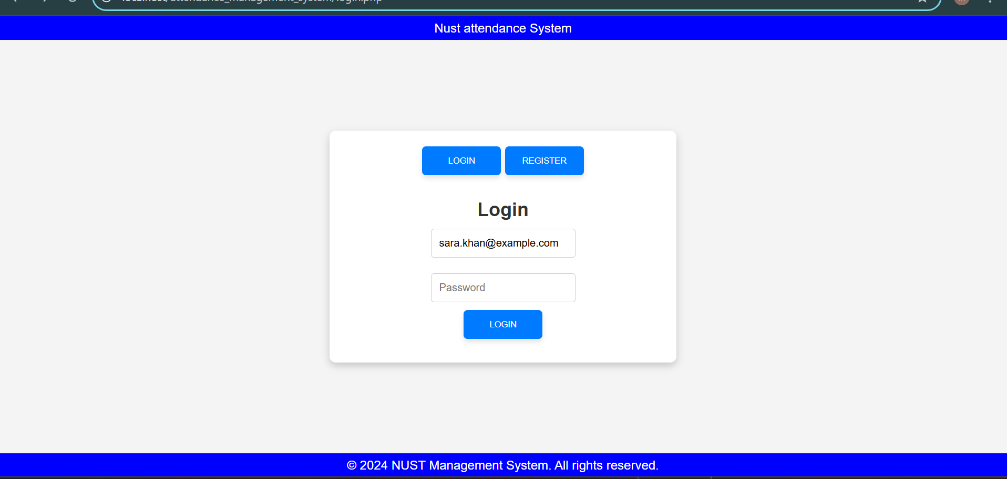

Teacher.php

Markattendance.php

student.php



## Data insertion using phpMyAdmin

INSERT INTO `user` (`id`, `fullname`, `email`, `class`, `role`) VALUES

(1, 'Ali Ahmed', 'ali.ahmed@example.com', 'A1', 'student'),

(2, 'Sara Khan', 'sara.khan@example.com', 'A1', 'student'),

(3, 'Hassan Malik', 'hassan.malik@example.com', 'B1', 'student'),

(4, 'Fatima Noor', 'fatima.noor@example.com', 'B1', 'student'),

(5, 'Dr. Imran', 'imran@example.com', '', 'teacher'),

(6, 'Prof. Ayesha', 'ayesha@example.com', '', 'teacher')

;

INSERT INTO `class` (`id`, `teacherid`, `starttime`, `endtime`, `credit_hours`) VALUES

(1, 5, '09:00:00', '10:30:00', 3),

(2, 6, '11:00:00', '12:30:00', 3),

(3, 5, '14:00:00', '15:30:00', 4);

INSERT INTO `attendance` (`classid`, `studentid`, `isPresent`, `comments`) VALUES

(1, 1, 1, 'Attended on time'),

(1, 2, 0, 'Absent due to illness'),

(1, 3, 1, 'Attended'),

(1, 4, 1, 'Participated actively'),

(2, 1, 1, 'On time'),

(2, 2, 1, 'Present but late'),

(2, 3, 0, 'Absent'),

(2, 4, 1, 'Attended'),

(3, 1, 0, 'Missed class'),

(3, 2, 1, 'Active participation'),

(3, 3, 1, 'On time'),

(3, 4, 1, 'Attended and participated'); INSERT INTO `user` (`id`, `fullname`, `email`, `class`, `role`) VALUES

(1, 'Ali Ahmed', 'ali.ahmed@example.com', 'A1', 'student'),

(2, 'Sara Khan', 'sara.khan@example.com', 'A1', 'student'),

(3, 'Hassan Malik', 'hassan.malik@example.com', 'B1', 'student'),

(4, 'Fatima Noor', 'fatima.noor@example.com', 'B1', 'student'),

(5, 'Dr. Imran', 'imran@example.com', '', 'teacher'),

(6, 'Prof. Ayesha', 'ayesha@example.com', '', 'teacher')

;

INSERT INTO `class` (`id`, `teacherid`, `starttime`, `endtime`, `credit_hours`) VALUES

(1, 5, '09:00:00', '10:30:00', 3),

(2, 6, '11:00:00', '12:30:00', 3),

(3, 5, '14:00:00', '15:30:00', 4);

INSERT INTO `attendance` (`classid`, `studentid`, `isPresent`, `comments`) VALUES

(1, 1, 1, 'Attended on time'),

(1, 2, 0, 'Absent due to illness'),

(1, 3, 1, 'Attended'),

(1, 4, 1, 'Participated actively'),

(2, 1, 1, 'On time'),

(2, 2, 1, 'Present but late'),

(2, 3, 0, 'Absent'),

(2, 4, 1, 'Attended'),

(3, 1, 0, 'Missed class'),

(3, 2, 1, 'Active participation'),

(3, 3, 1, 'On time'),

(3, 4, 1, 'Attended and participated');

## Data insertion

